DAT 515 uCertify Lab Activity Worksheet

Module Labs
20.3.4
20.3.5
20.3.6
20.4.1
21.1.1
21.1.2
21.1.3

Lab Screenshots
20.3.4
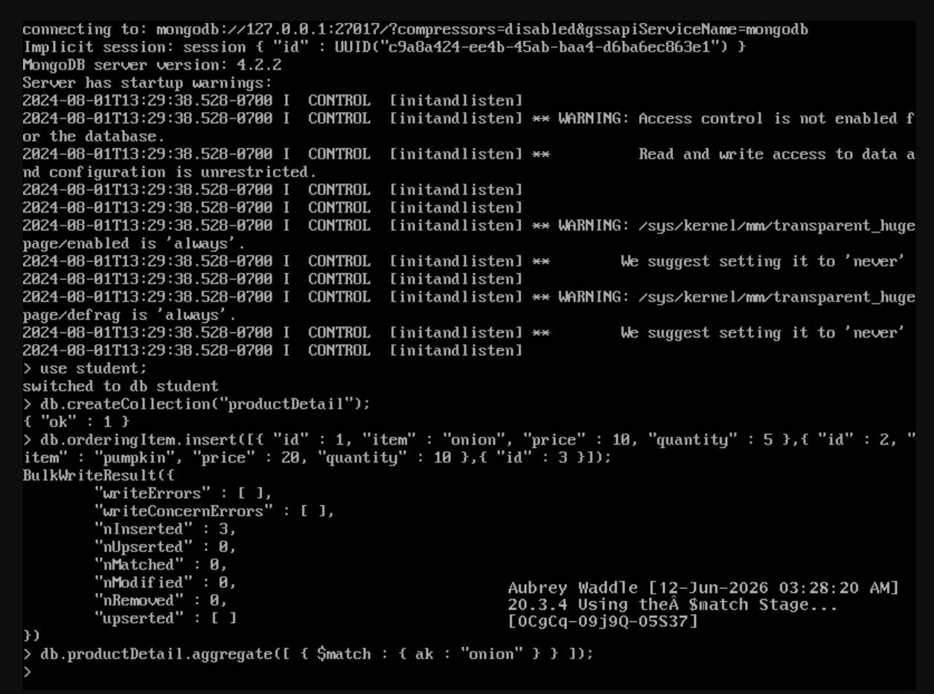
20.3.5
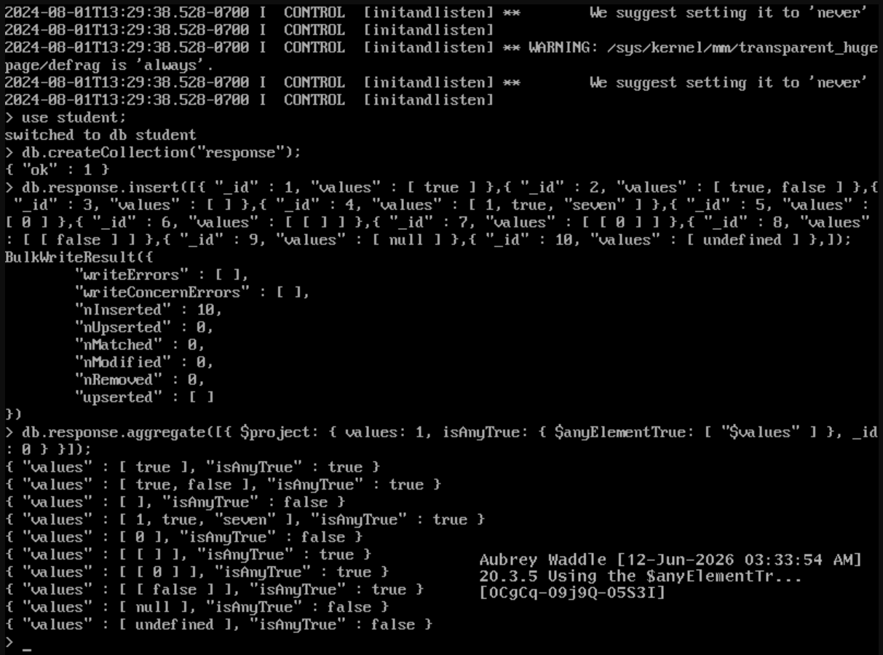
20.3.6
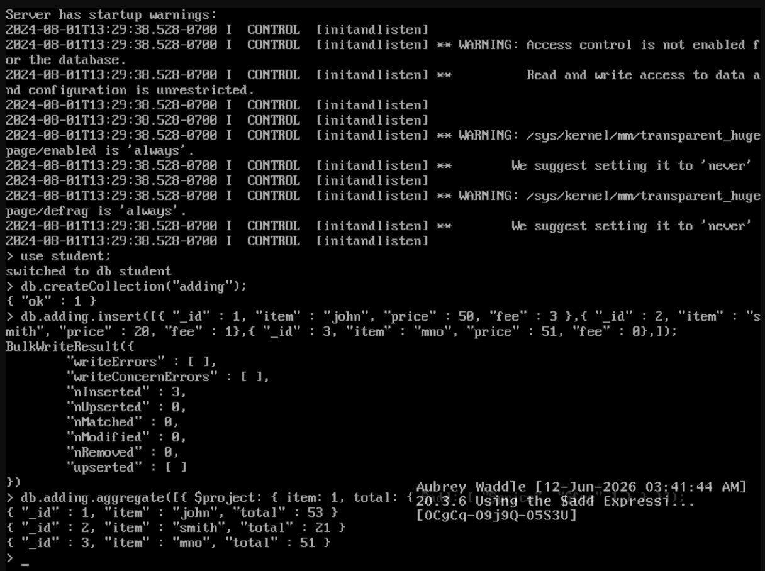
20.4.1
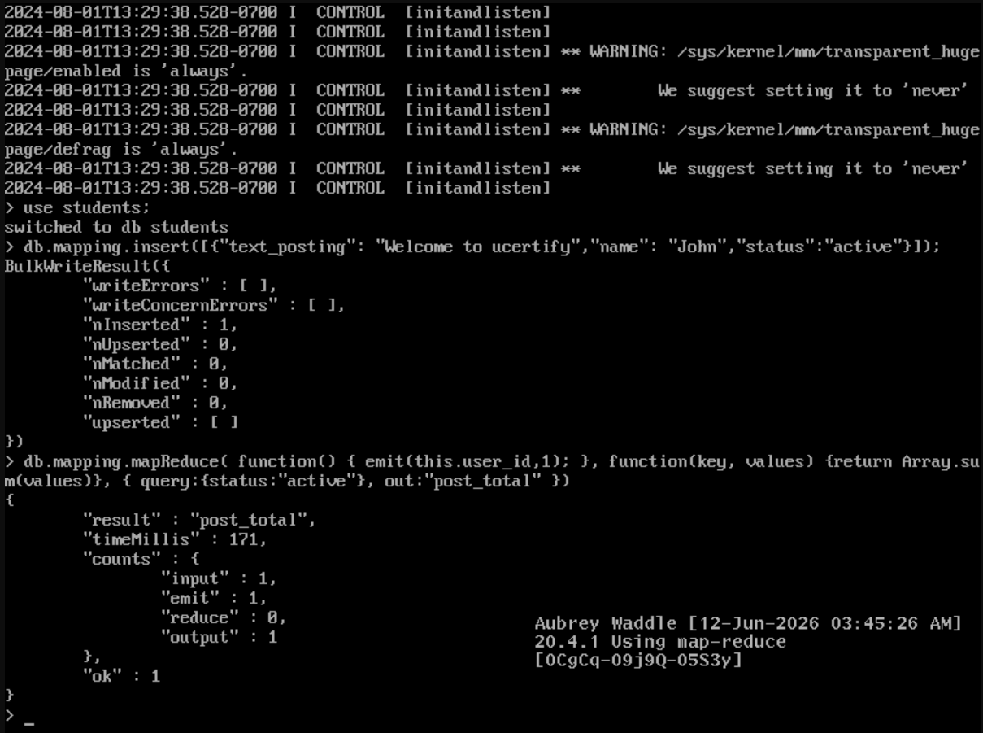
21.1.1
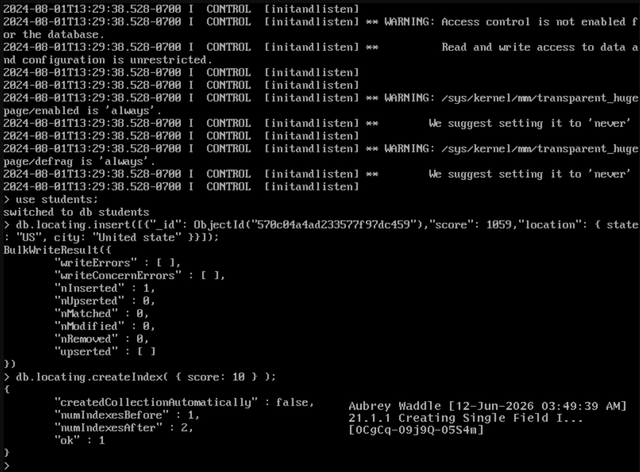
21.1.2
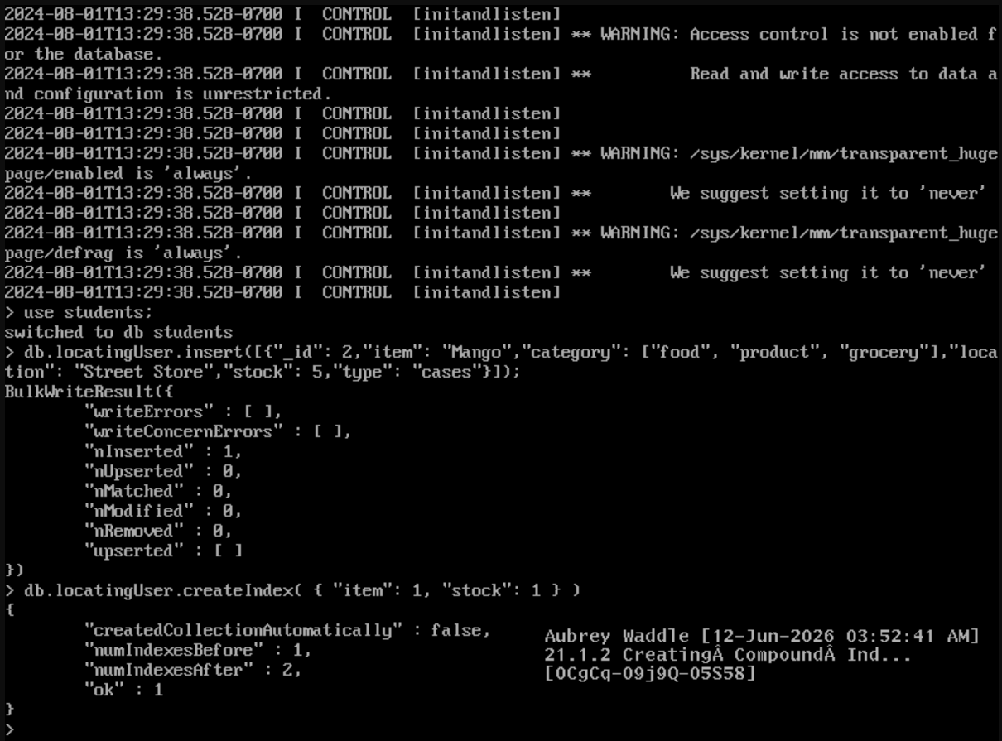
21.1.3
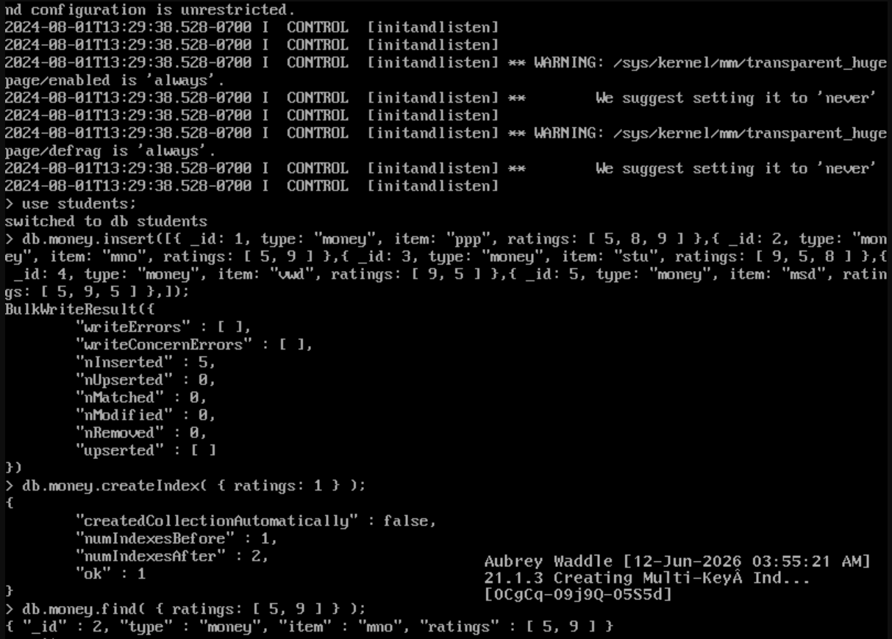

Lab Reflection

20.3.4
In this lab, I was able to use MongoDB's aggregate architecture and use the $match stage to filter documents. I made a collection and added some sample records. Then I filtered out documents that didn't meet the requirements with $ match . Conceptually it was like a SQL where clause, but it was done as part of an aggregation pipeline. They are useful tactics when database developers, analysts or administrators want to rapidly filter large amounts of data prior to more detailed research.
20.3.5
In this lab, the expression $anyElementTrue is used to assess the array data. I created documents with different array values and used an aggregate pipeline with $project to test whether any element in each array evaluated to true. In this activity , we were dealing with logic based evaluation of data inside arrays . In previous aggregation labs , we were summarizing or filtering data . This technique will be valuable for developers and analysts working with data sets where there are several values in a single field – think survey responses or status flags.
20.3.6
In this lab, I created a collection with fee and price data and used the $add expression to add them. The process was rolled up into a new calculated field, and the source documents were not affected. Instead than focusing on data filtering or grouping, this lab focused on doing mathematical operations during query execution. If you need to develop computed metrics on stored data, you’ll require these talents for financial reporting, sales analysis and all of this kind of thing.
20.4.1
In this lab we explored MongoDB's map-reduce approach, which is used to evaluate and summarize data. I created map and reduce functions and populated with some example entries to find the number of records fulfilling a certain requirement. In Map-Reduce , the data is processed and summarized using JavaScript functions . This is different from the phases of an aggregate pipeline . This approach will be valuable for developers with sophisticated analytical needs that cannot be effectively fulfilled by conventional aggregation processes, and for those doing big scale data processing.
21.1.1
In this lab I was able to speed up the search by creating a single-field index on a collection. I loaded some sample data and created an index on the score field and then watched how MongoDB used it. The lab’s focus was on database optimization, not data handling or analysis. These are important skills for developers and database administrators supporting systems that need fast searches and queries.

21.1.2
In this lab we extended the ideas on indexing to create a compound index across many fields. I populated it with sample inventory data . I created an index on the item and stock fields to speed up queries . This time it is about improving multi-field searches, unlike the previous indexing lab. Composite indexes are extremely useful for business applications where users frequently filter and search data based on multiple criteria.
21.1.3
In this lab I worked with papers with array values and I created a multikey index on the ratings field. Then I built a number of indexes and searched the collection for papers with specified rating values. In this lab we indexed array based data not just single values. This was different than the prior indexing labs. Multikey indexes are very useful for applications that hold document attributes with numerous values, such as tags, ratings, categories, and so on.

